Hash function:

Perform the attack on the hash function based on the default files. (Analysis -> Hash -> Attack on the hash value of the digital signature):
16- bit length using MD2:
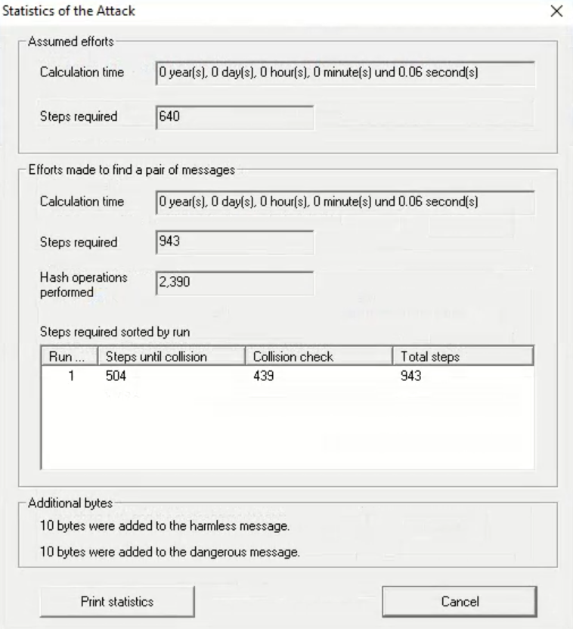
16- bit length using md4:
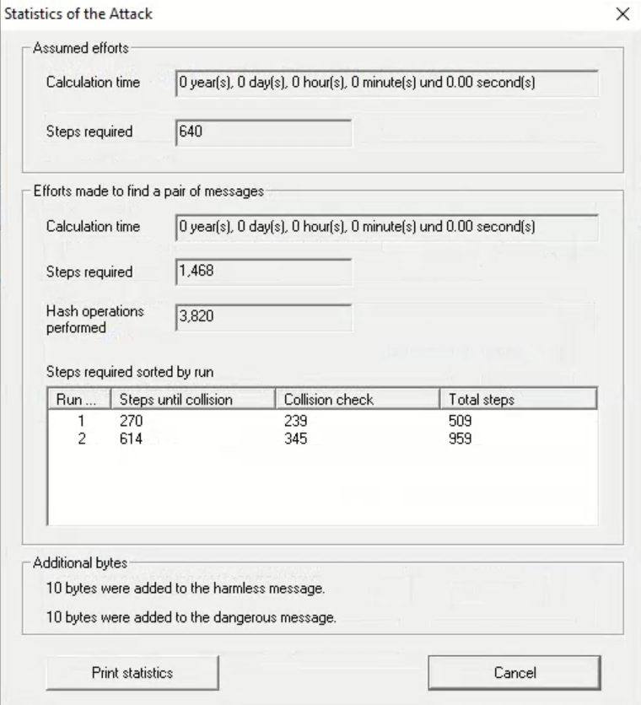
16-bit length using MD5:
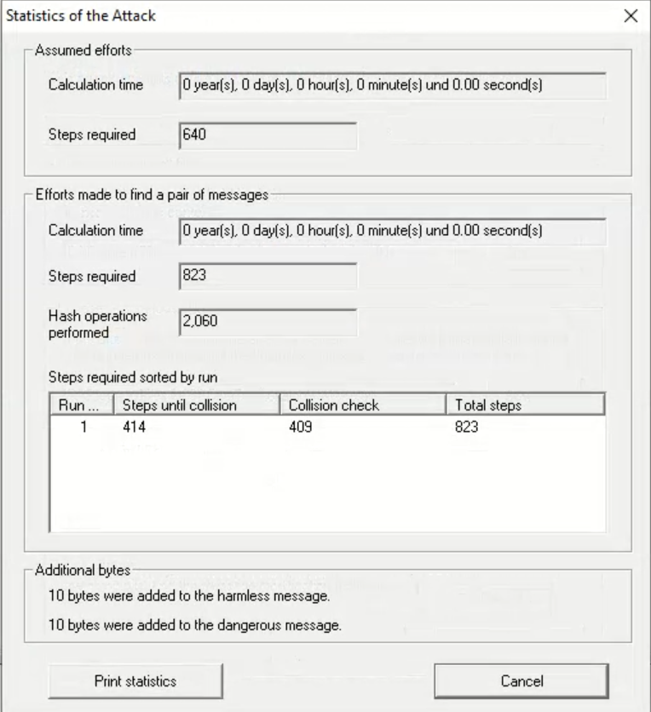
16-bit length using SHA:
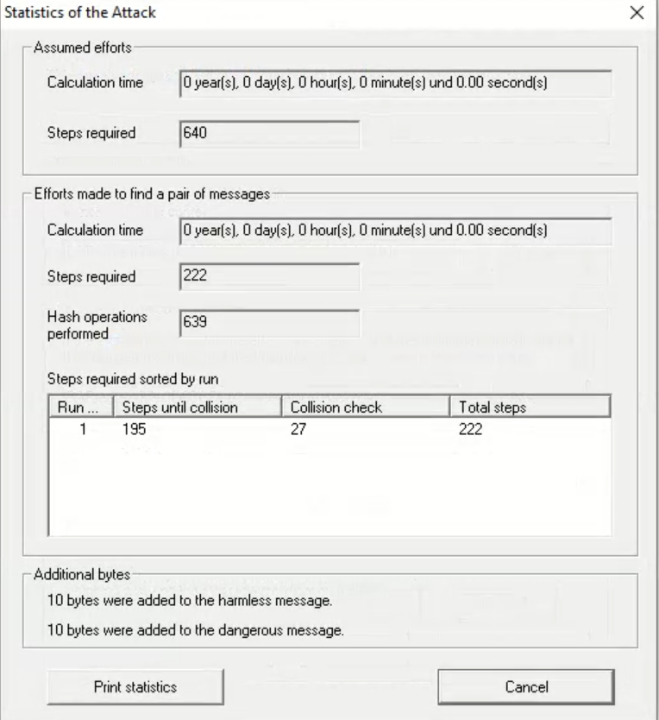

16-bit length using SHA-1:
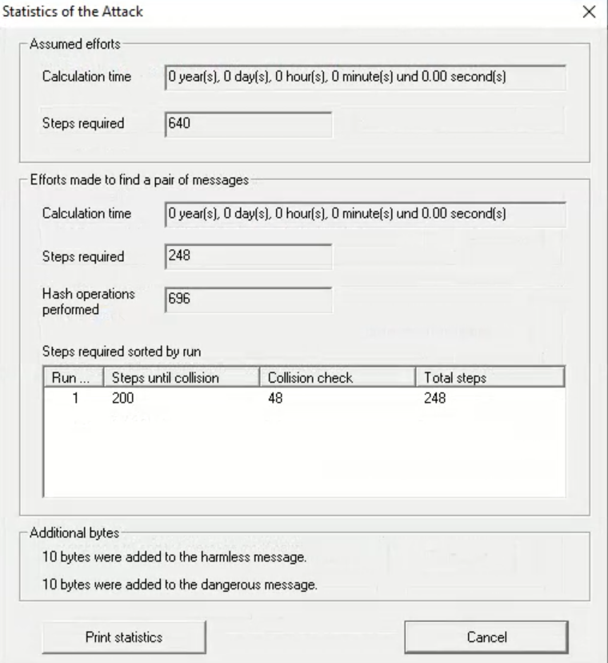

Perform the attack again, but change the hash function and the significant bit length (at least two others):
32-bit length using MD2:
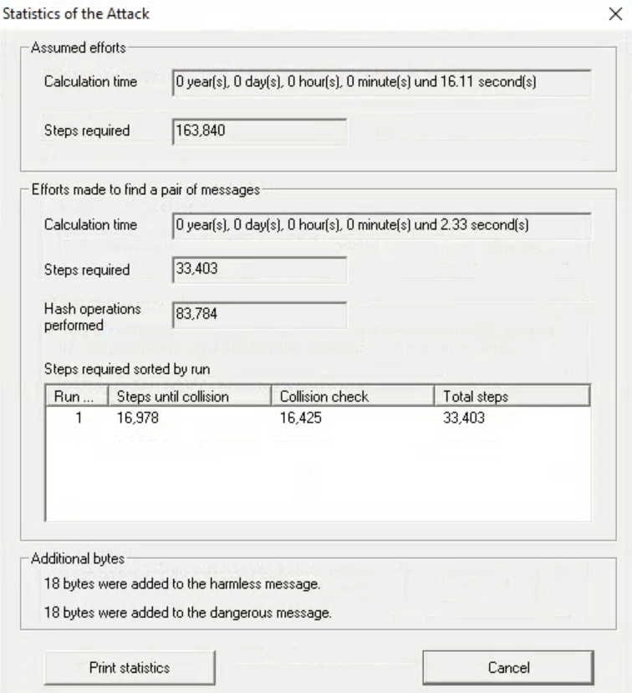

32-bit length using MD4:
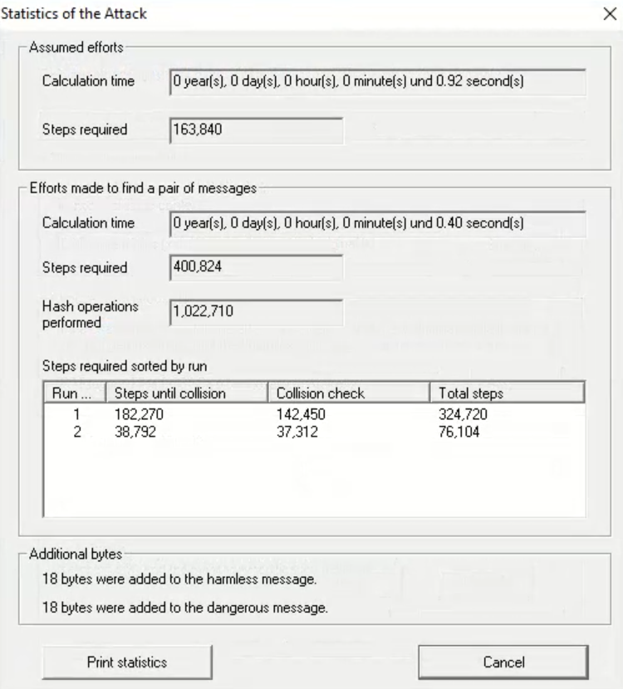
32-bit length using MD5:
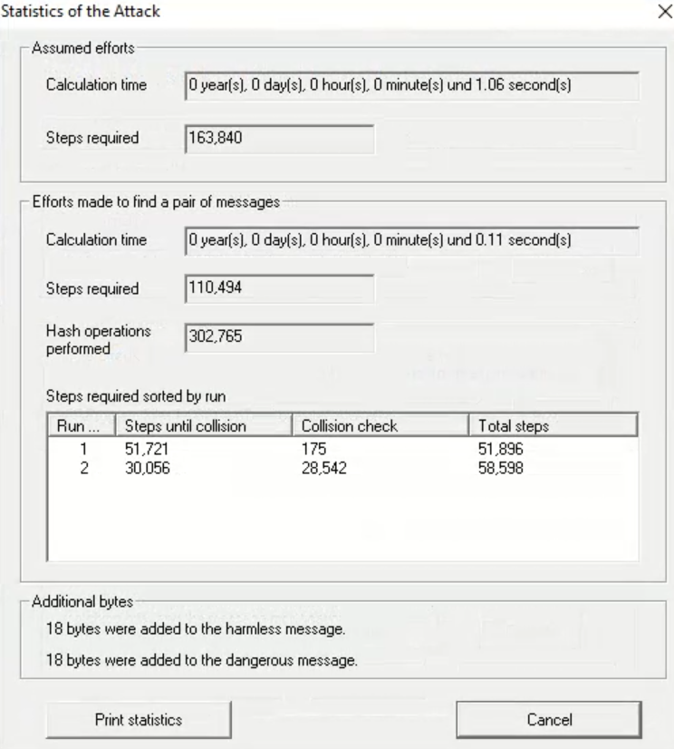
32-bit length using SHA:
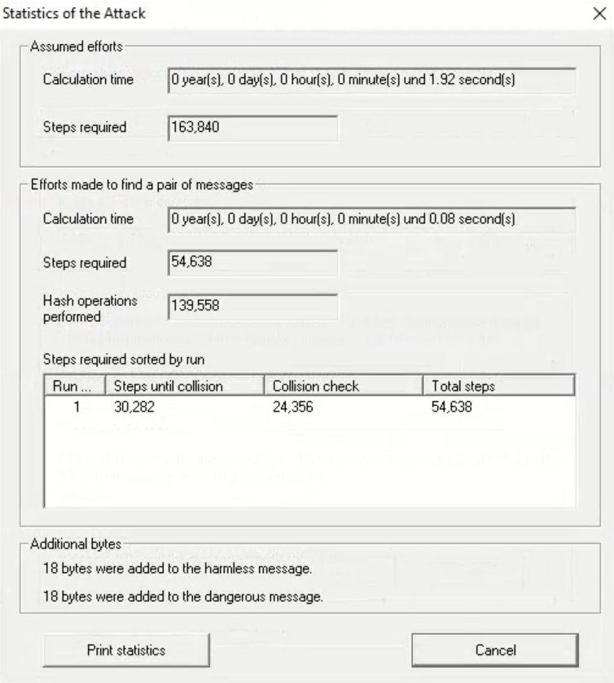
32-bit length using SHA-1:
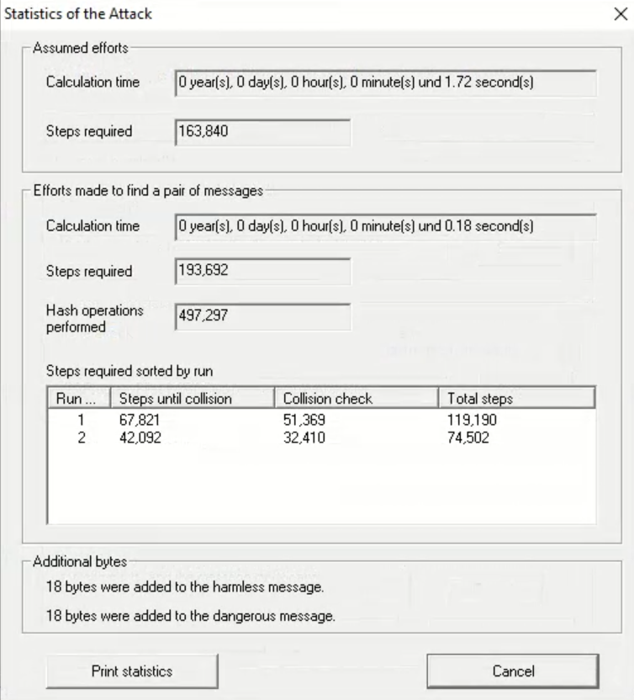

40-bit length using SHA:
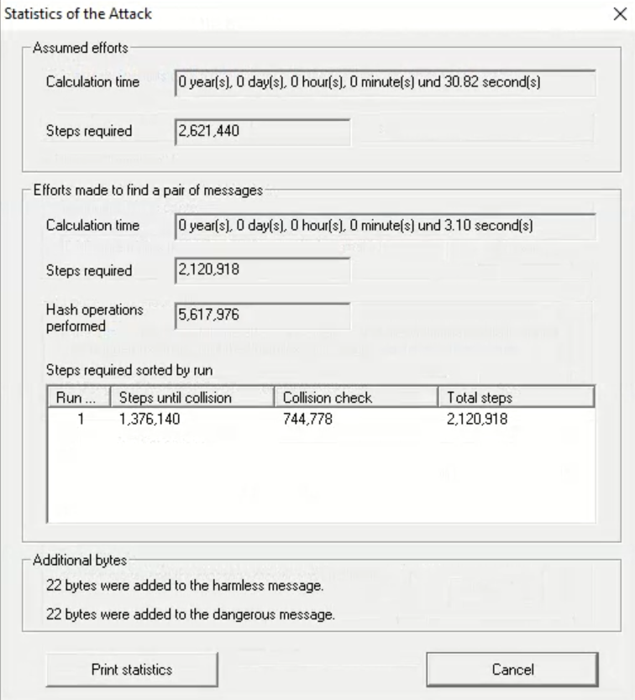
40-bit length using SHA-1:
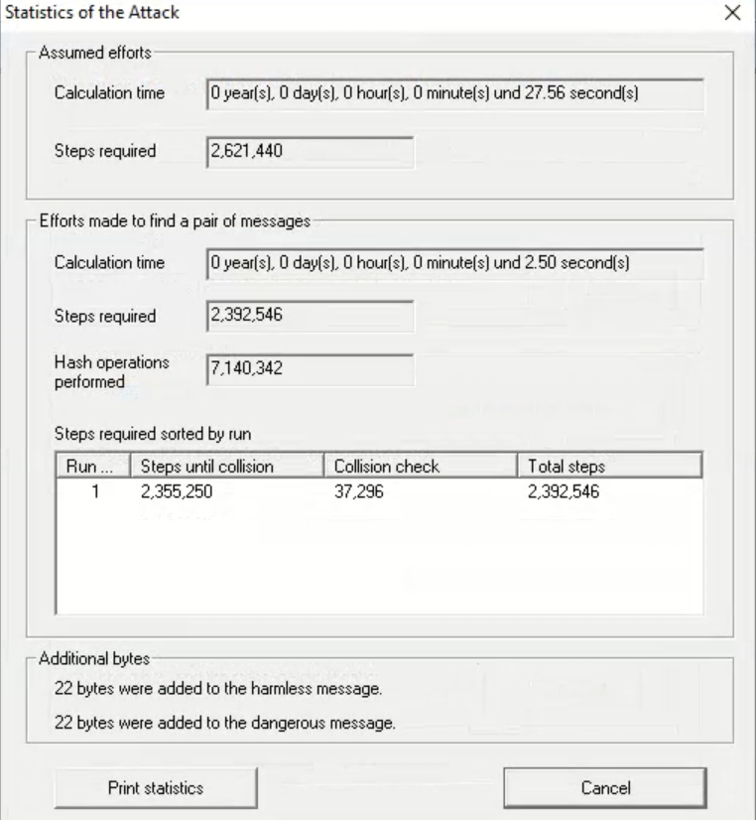
40-bit length using MD2:
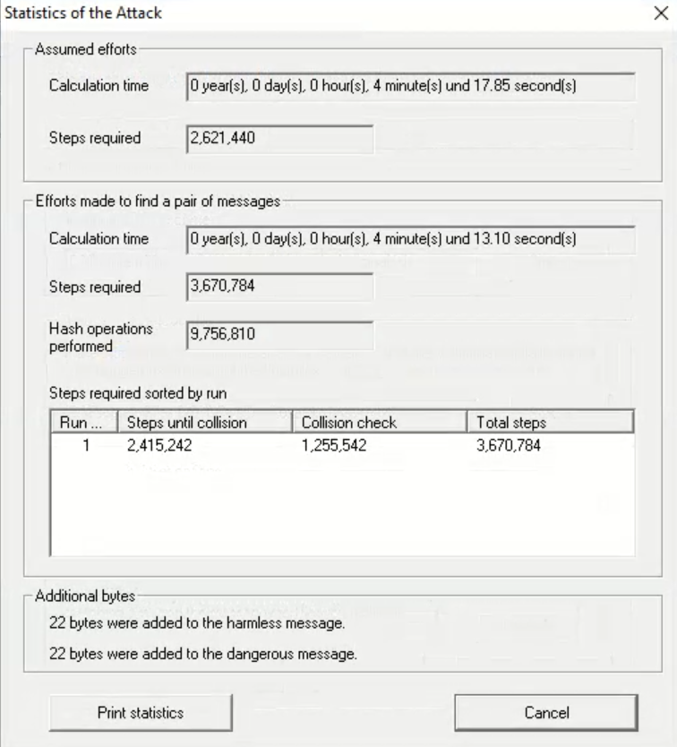
40-bit length using MD4:
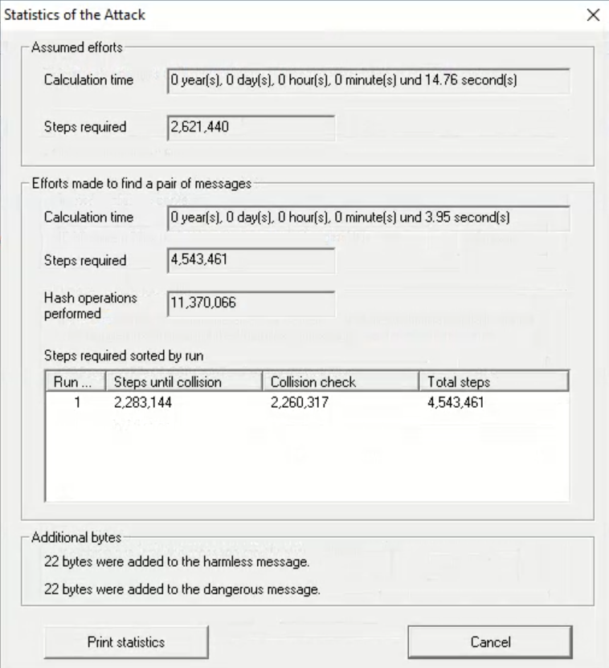

40-bit length using MD5:
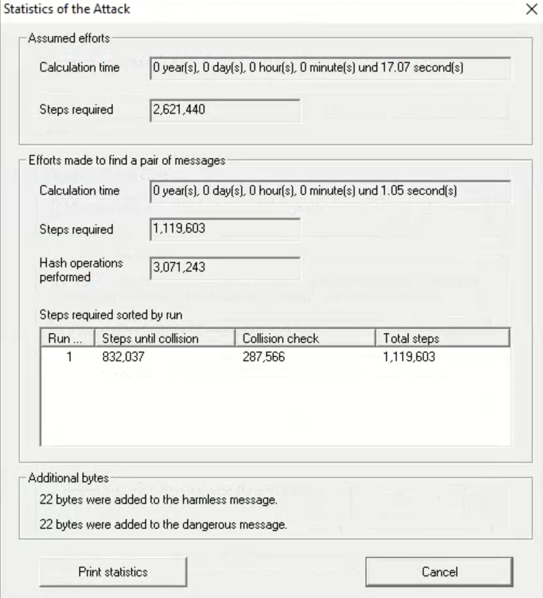
Here is a summary about the time it takes to crack the hashes:
 | MD2 | MD4 | MD5 | SHA | SHA-1
16-bit | 0.06 s | 0.00 s | 0.00 s | 0.00 s | 0.00 s
32-bit | 2.33 s | 0.40 s | 0.11 s | 0.08 s | 0.18 s
40-bit | 4 min 13.10 s | 3.95 s | 1.05 s | 3.10 s | 2.50 s

How does changing the key length affect the time of the attack?
Increasing the number of significant bits increases the attack time exponentially. The expected effort is proportional to 2^{n/2}; for example, increasing from 24 to 40 bits makes the attack roughly 256 times slower

Does the selection of the hash function affect the time of the collision search task (attack)?
Yes. The expected computational effort grows with the hash output length, but the actual wall-time depends on the function’s per-hash speed and whether cryptanalytic attacks exist. Therefore choose a hash with sufficient digest length and no known practical collision attacks.

What is the advantage of an attack (finding a collision) whose aim is to modify two documents than one?
Finding a collision between two documents is much more practical than attacking a single target because it is exponentially cheaper and allows signature replay/substitution, enabling a forger to obtain a valid signature on a benign file and transfer it to a malicious one without breaking the signer’s key.

Can the hash function be regarded as safe? If so, for which parameters?
The hash function is secure only when a modern, unbroken algorithm such as SHA-2 or SHA-3 is used with a enough digest length (e.g., SHA-256 for 128-bit collision security or SHA-512 for 256-bit security). Shorter digests or obsolete hashes like MD5 and SHA-1 are no longer considered secure.

What types of problems have been identified for popular hash functions (MD5, SHA)?
Popular legacy hashes such as MD5 and SHA-1 suffer from practical collision and chosen-prefix attacks, reduced security margins, and structural weaknesses like length-extension. These flaws make them unsuitable for digital signatures or integrity verification; modern systems should use SHA-2 or SHA-3 instead.

Key exchange - Diffie-Hellman protocol:
Checking if machines are connected:
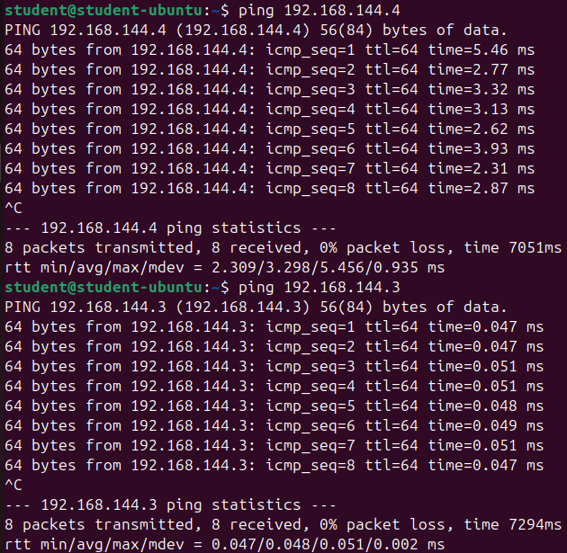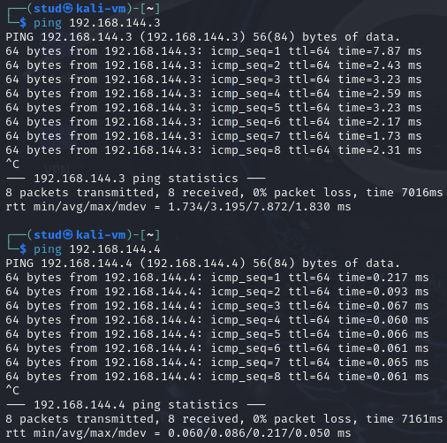

Generate the Diffie-Hellman common public key for both clients:

openssl genpkey -genparam -algorithm DH -out dh_com_pub.pem
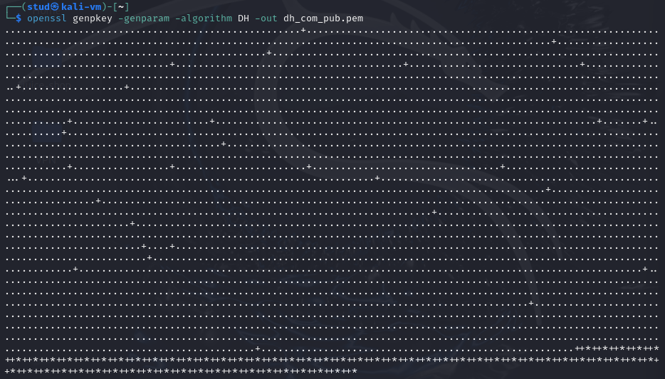

To display the common key, use:

Encoded form:

cat dh_com_pub.pem
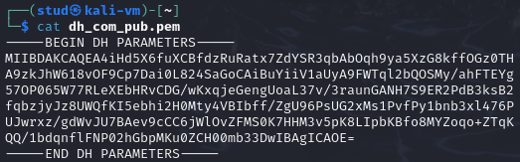

Text form:

openssl pkeyparam -in dh_com_pub.pem -text
After sharing the same p and g from Kali to Ubuntu in any public media as p and g can be public:
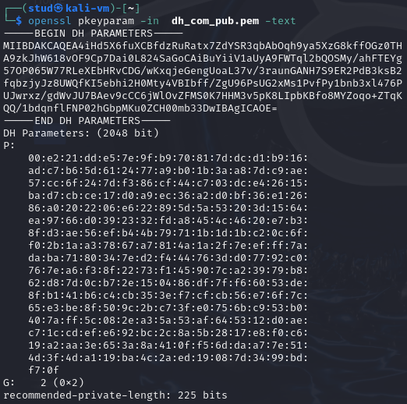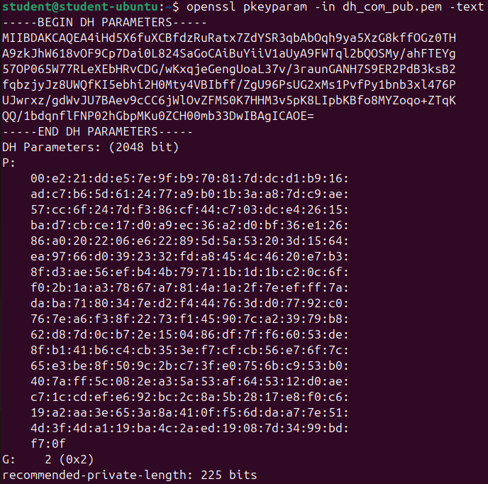
Displays the parameters of a public key -> Specifically for Diffie-Hellman (DH) keys.

Based on common DH key, each client should generate their private keys:

openssl genpkey -paramfile dh_com_pub.pem -out dh_client1_key.pem
Each part must create a private key (client1 -> a and client2 -> b) so they can share each public key given p,g: $A=g^{a}(mod p)$ for client 1 (Kali) and $B=g^{b}(mod p)$ for client 2 (Ubuntu)

List the key:

openssl pkey -in dh_client1_key.pem -text -noout
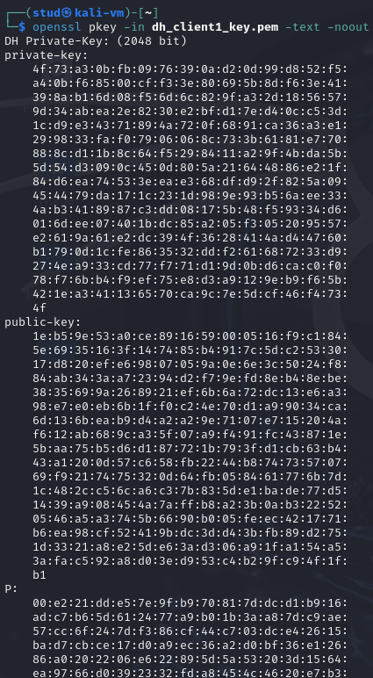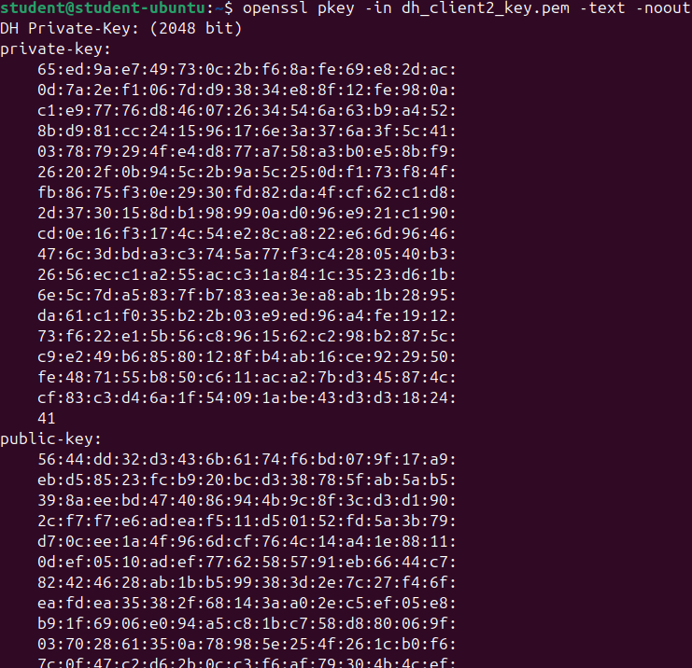
A different public key/private key for every client.

Extract the public key based on the private key:

openssl pkey -in dh_client1_key.pem -pubout -out dh_client1_pub_key.pem

Exchange the public keys of the client between them and generate the shared secret key:
After sharing the public keys between client1 and client2:

openssl pkeyutl -derive -inkey dh_client1_key.pem -peerkey dh_client2_pub_key.pem -out secret_key1.bin

Compare the shared secret keys using cmp command:
Only for testing purposes I exposed the client2 private key to kali just to check if they were equal:
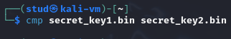
As no output is shown, the files are equal.

Create a hex dump of the shared secrets using xxd command:
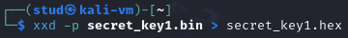
Having both the same secret key of 2032 bits:
7e82e1f080e6a613764c2f1c2b38b642006e6195c0912ee0bda298759955
17c00c3291ba85dbb59d8cbb385c6140c834e0799588a9f155984b75bce8
b07cfd37724311e08ddf5e2087bbc394abd8e529a37996071618e1d59430
adac76c78d4f33e0de6af34677749d5d00e96c7b2b100d38272a0e2ca65c
e2983b972ff9efc14d2e3841beb0562c68d42d0c1744e0f6ea1898a9d447
9ff033ca6c9cea335757afc7649ee796064ac4e3c49d0ca4c75130215a1d
5eb01998c6b71ad605864d7d347386ca38626f9f7b37ae84ca97ac8adafe
3382cbd96013f06073bbb1a6a07781e1d6e420ede188d786a1fbb21026d5
6de958cafeb70532fee52c50dc20c035

Which key exchange algorithm guarantees higher security? RSA versus DH. Why?
- DH (Diffie–Hellman), when used ephemerally (DHE/ECDHE), is stronger in practice because it provides perfect forward secrecy: compromise of a long-term private key does not reveal past session keys.
- RSA key-transport (static RSA encrypting a premaster secret) does not provide forward secrecy. If the RSA private key is later compromised, past session secrets can be recovered.
- Cryptographic hardness: RSA security relies on integer factoring, DH on the discrete logarithm problem (or ECDH on the elliptic-curve discrete log). For comparable bit-sizes, ECDH gives more security per bit than classical DH/RSA.
- Practical note: both are broken by large quantum computers (Shor’s algorithm), but for current classical adversaries ephemeral DH is generally preferred.

What are the risks for entities using DH key exchange protocol?
The 4 main problems are:
- Unauthenticated exchange (MitM): Without authentication, attackers can intercept and replace public keys, creating separate shared secrets with each victim.
- Weak or malicious parameters: Using small or attacker-chosen primes/generators makes the key mathematically breakable.
- Poor randomness or key reuse: Predictable or reused private values expose the shared secret and destroy forward secrecy.
- Implementation flaws: Timing leaks, invalid-group values, or side-channel attacks can reveal private exponents.

What are the other methods to determine a common cryptographic key?
- Public-key encryption (RSA) key transport -> sender encrypts a secret to receiver’s public key.
- Password-Authenticated Key Exchange (PAKE) -> SRP, J-PAKE, OPAQUE (secure password-based key agreement).
- Key Distribution Center (KDC) protocols -> e.g. Kerberos.
- Pre-shared keys (PSK) -> manual or out-of-band distribution.
- Elliptic-curve variants of DH -> ECDH, X25519 (modern, efficient).
- Hybrid KEX (TLS style) -> combine public-key auth (certificates) + ephemeral DH for forward secrecy.
- Physical exchange (USB, QR, NFC) or secure courier.
- Quantum Key Distribution (QKD) (specialized hardware).
- After a shared secret is derived, use a KDF (HKDF etc.) to produce session keys.

Which element of the DH protocol is not transferred between clients? How does this affect security issues?
- Not transferred: each party’s private exponent (the secret $a$ or $b$) is never sent. Only the public values ($g^{a}(mod p)$, $g^{b}(mod p)$) are exchanged.
- Security effect: keeping private exponents secret prevents any eavesdropper who only sees $g^{a}(mod p)$/$g^{b}(mod p)$ from computing the shared key (assuming discrete log is hard). If a private exponent leaks or is reused, the shared key(s) are compromised and forward secrecy is lost. Also means attackers can only break the protocol by solving the discrete log or by MitM / replacing public values.

Check whether the last point has managed to establish the same key for both clients. Include the content of the agreed secret key in the report.
The shared private key is:
7e82e1f080e6a613764c2f1c2b38b642006e6195c0912ee0bda298759955
17c00c3291ba85dbb59d8cbb385c6140c834e0799588a9f155984b75bce8
b07cfd37724311e08ddf5e2087bbc394abd8e529a37996071618e1d59430
adac76c78d4f33e0de6af34677749d5d00e96c7b2b100d38272a0e2ca65c
e2983b972ff9efc14d2e3841beb0562c68d42d0c1744e0f6ea1898a9d447
9ff033ca6c9cea335757afc7649ee796064ac4e3c49d0ca4c75130215a1d
5eb01998c6b71ad605864d7d347386ca38626f9f7b37ae84ca97ac8adafe
3382cbd96013f06073bbb1a6a07781e1d6e420ede188d786a1fbb21026d5
6de958cafeb70532fee52c50dc20c035

